

Ciocîrtău Cosmin

Master 2023

Water Dispenser

Requirements

1. The water dispenser can output cold water or hot water. The hot water is heated on the spot (somehow).
2. The Simulink model has the following inputs and outputs:

Inputs:

* Water button (boolean)
* HotWater button (boolean)
* SelfTest button (boolean)
* Pour Value (number, 2 to 3) (Additional)
* Water level sensor (number, 0 to 1000 ml)
* Water temperature sensor (number, 0 to 100 degrees Celsius)

Outputs:

* + Activate Water Heater (boolean)
  + Activate Water Pouring (boolean)
  + Machine Status (integer):
* 0 = IDLE
* 1 = WORKING
* 2 = NO_WATER
* 3 = HEATER_FAULT
* 4 = POURING_FAULT
* 5 = TESTING... (Additional)

1. The process is as follows:

• When pouring normal water:

– Start pouring water when Water=TRUE (i.e. user presses button)

– Stop when Water=FALSE

• When pouring hot water:

– When HowWater=TRUE (i.e. user presses button), activate the water heater

and wait for 500 milliseconds. Don’t pour any water yet.

– Only afterwards start pouring water

– Stop when HotWater=FALSE

1. All buttons must be debounced both ways, with a time duration of 0.2 seconds.
2. There is a separate self-test mode, activated via the SelfTest button. The procedure

is as follows:

* + Start heating water. If the temperature doesn’t reach 99 degrees in 20 seconds, there is a heater error. The error must be signalled by setting Status = HEATER FAULT for at least 10 seconds.
  + Start pouring water. If the water level doesn’t drop by 50ml in 2 seconds, the pouring mechanism is blocked (i.e. limestone). The error must be signalled by setting Status = POURING FAULT for at least 10 seconds.

1. Use parameters from Matlab for all values you consider necessary (e.g. duration of

times etc.). Our customer may want to adjust the parameters at any time.

1. Test your state machine (use one/multiple separate test models if necessary).
2. Additional, I added from me requirements for WORKING and NO_WATER modes. I implemented an IDLE block which means an ultra power saving mode. I implemented LEDs to see in real-time the status of the machine (Working, Fault, Testing). I implemented a system which counting how much water is pouring (tells us when we have no water remaining in the container of the machine).

Main design

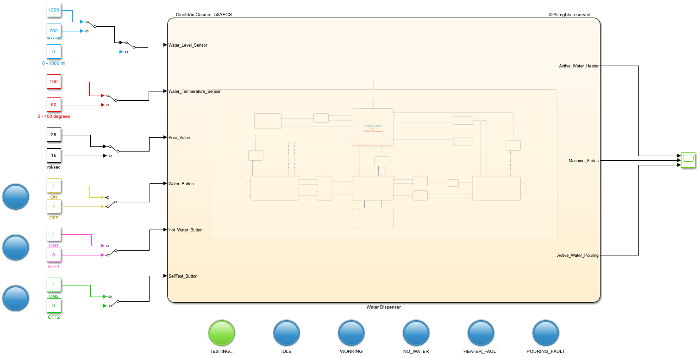

Description:

* We have 6 inputs and for any of them I used switches which allow me to change the value for any input very easy. For boolean inputs I used 1 or 0. For integer I used different values (e.g. at Water_Level_Sensor I can have any value between 0 and 1000).
* We have 3 outputs which will be viewed by scope. Active Water Heater will be a boolean signal (0/1), machine status will be viewed like a digital signal that grows and decreases in steps because we can have only 6 integer values (0, 1, 2, 3, 4, 5).
* The LEDs from the left side are used only for buttons from input. They tell us if the button from the right part is ON (1) or OFF (0). The LEDs from bottom side tell us the status of the machine, which can be Testing, Idle, Working, No_Water, Heater_Fault and Pouring_Fault. Blue color means that the LED is OFF.

Finite State Machine

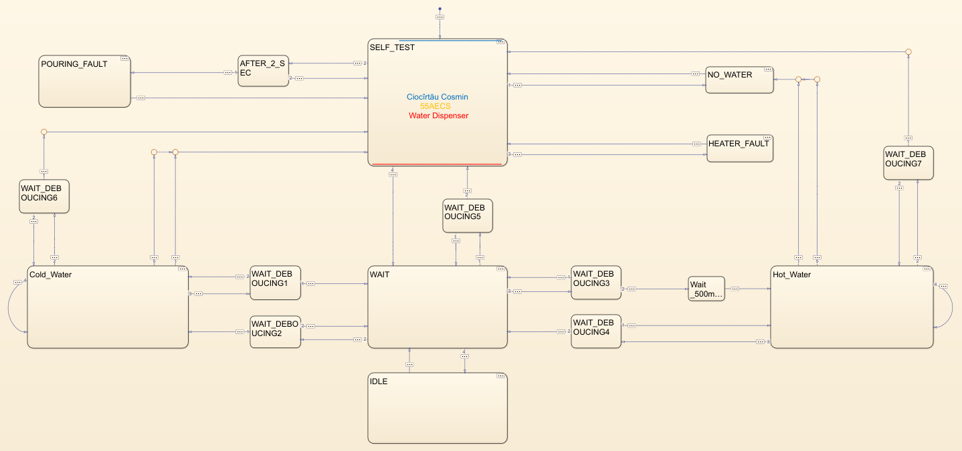

Our Finite State Machine is built from 5 main blocks:

1. Self_Test;
2. Wait;
3. Cold_Water;
4. Hot_Water;
5. Idle.

Description:

* SelfTest is highest priority block because it can be accessed from any state you are. It represent the block which verify all the functionality of the machine (e.g. Water level, Heater functionality).
* Wait is the block where the machine waits for next command from user; this can be a requirement for cold water or for hot water.
* Cold_Water is the block which allows the water to pouring while we have water enough.
* Hot_Water is a block as cold water but this time the machine pouring hot water.
* Idle is an ultra power saving energy mode which (in real life) can stop all LEDs to save more energy.

How it works

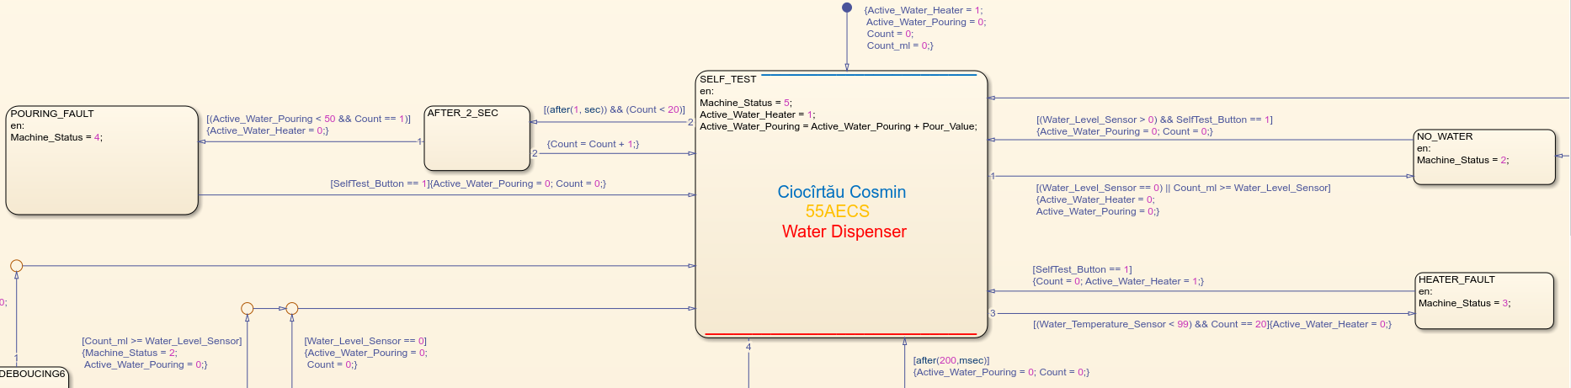

Initially, we turn on the Active_Water_Heater, Active_Water_Pouring and initialize the Count and Count_ml with 0. Count is use to increment the Active_Water_Pouring at every second with Pour_Value (input). Count_ml is used to count how much water has droped from the beggining, to know and verify if we have still remaining water in container.

Remember execution order from the next chart:

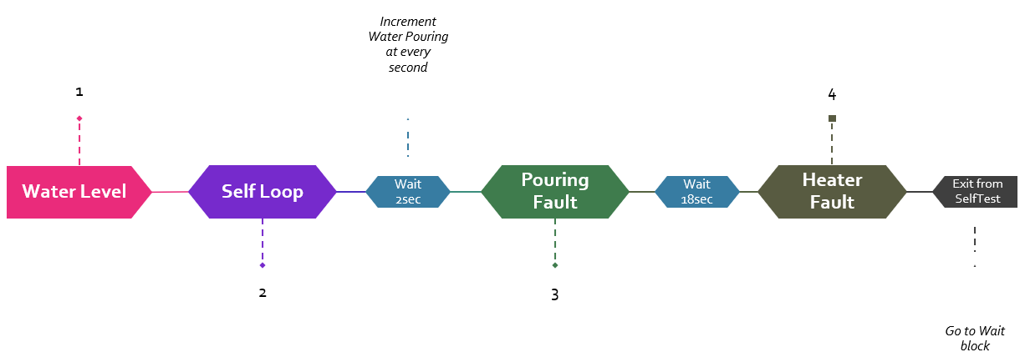

In SELF_TEST we verify first time the water level, because without water a water dispenser is useless even if the rest of functionality works fine. Second, we enter into a self loop for 20 seconds because, according to requirement from beggining, we need to verify if our machine can reach 99 degrees in 20 seconds. But this will be verified later. After 2 seconds maded in self loop, we verify if our system can drop 50ml water in 2 seconds. If the system doesn’t drop 50ml in 2 seconds, the pouring mechanism is blocked. Then, we verify if the temperature can reach 99 degrees in 20 seconds, if not, there is a heater error.

If the system pass all test, he goes into Wait block.

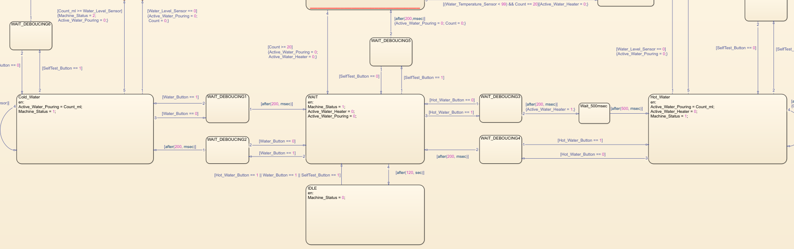

In Wait block, we do nothing, just wait for a next command, which can be a require for Cold_Water, Hot_Water, Idle mode or even to go back to SelfTest block.

If the Water_button is activated still after 200ms (deboucing), the next state where the machine goes in is Cold_Water.

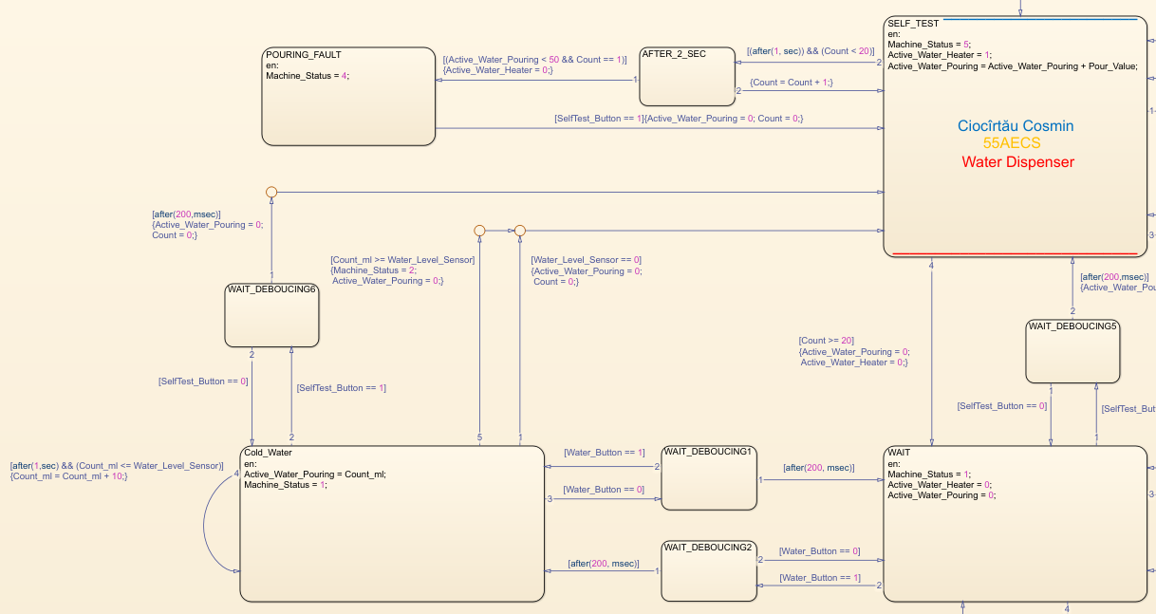

How long we are here, we’ll count how much water is droping. I used a value neither small nor large, so I supposed that the machine will drop 10ml/sec water. We have 3 options to exit from this state: if we have not water remaining in container (Count_ml >= Water_Level_Sensor), if we press SelfTest button and require for a new test of functionality, or if the Water_button is no longer pressed.

Back to the Wait block, we can also go to the Hot_Water if we press Hot_Water_Button. If the Hot_Water_Button is activated still after 200ms (deboucing), we activate Active_Water_Heater for 0.5 seconds and then the next state where the machine goes in is Hot_Water.

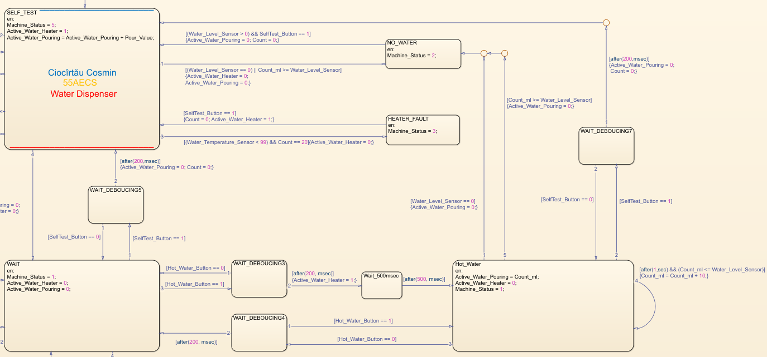

This state repeat the functionality of Cold_Water and the biggest difference is that for this state we use in plus the water heater. One observation is that Count_ml is further incremented and takes into account its previous value. For example, if we drop some other into Cold_Water block, and the Count_ml is now 230ml, the next time when the machine goes into Cold_Water or Hot_Water will continue to count from 230ml forward.

Back to the Wait block again, we can go also to Idle block, which represent a ultra power saving mode.

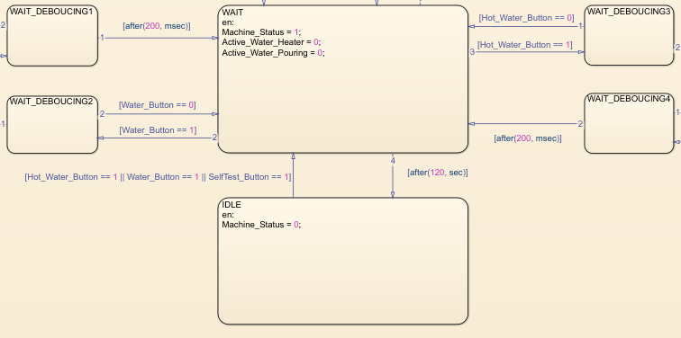

The exit from here is very simple because all we need to do is to press any button from the machine. In real life this block can represent that the machine will turn off all LEDs and extra functionality after some time, while the machine is not used. The machine will go to Idle if at least 120 seconds this is no used.

Observation: From any state we are, we can go anytime we want into SelfTest block to verify again the functionality of the FSM. This happen every time we press SelfTest_Button from input.

Simulation

Before simulation, we set next configuration for our model:

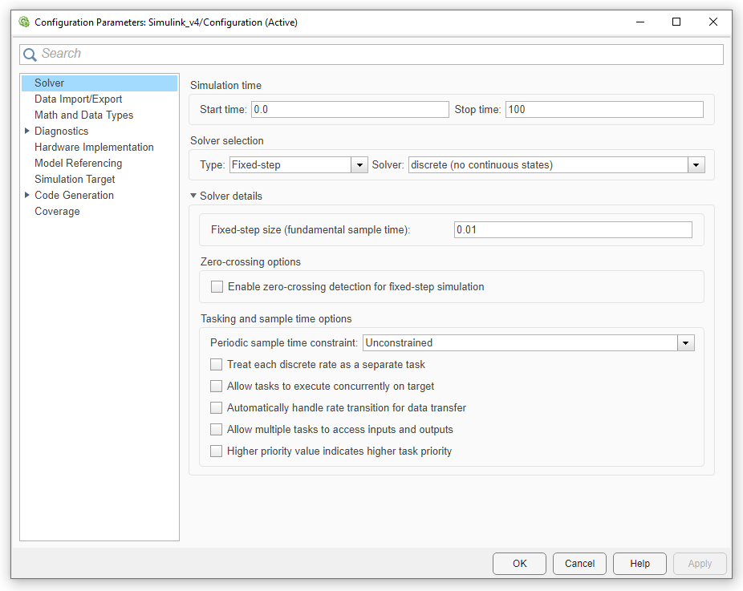

I set fixed-step size 0.01, because according to requirements we need to debounce the buttons at 200ms, and for example step size 1 or 0.5 is not properly. The program analyze the signals faster at 0.01 than 1 or 0.5.

In the graphs the signals are delayed with 0.01, exactly the step size.

Let’s supose that we have these 6 inputs:

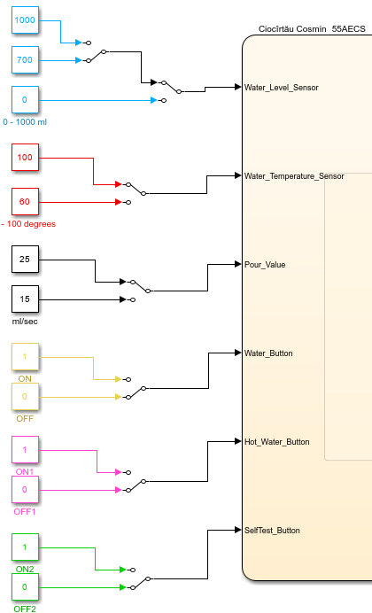

For the moment remember this: we have enough water, and the system meet all requirements to work well. The simulations looks like that (if you can’t see properly, please enlarge the images):

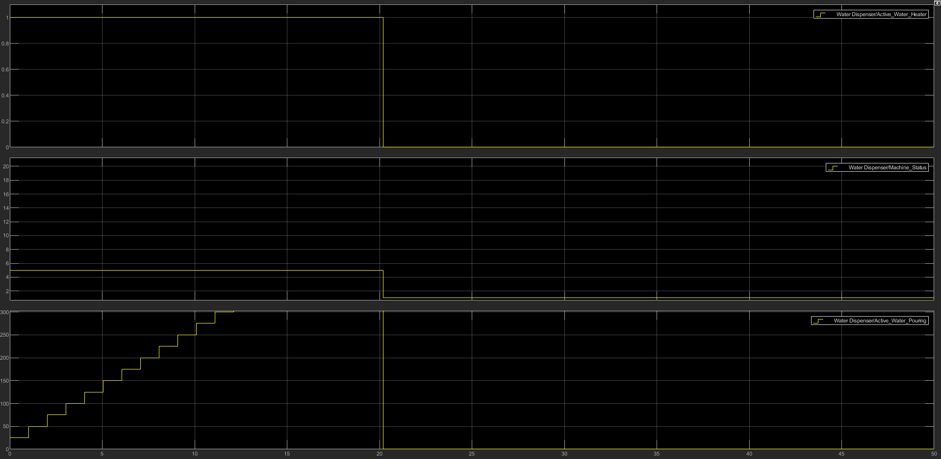

We can observe that the Active_Water Heater is ON for 20 seconds, Machine_Status has value 5 (Testing) for first 20 seconds but then has value 1 (Work), Active_Water_Pouring increase with 25 ml/sec till second 20. We can observe that imediately after 20 seconds (20 represent the and of the test), all outputs are changed.

* Water_Button = ON

Now, from Wait state, let’s supose that we activate Water_Button.

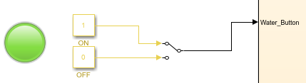

Let’s see how look the outputs:

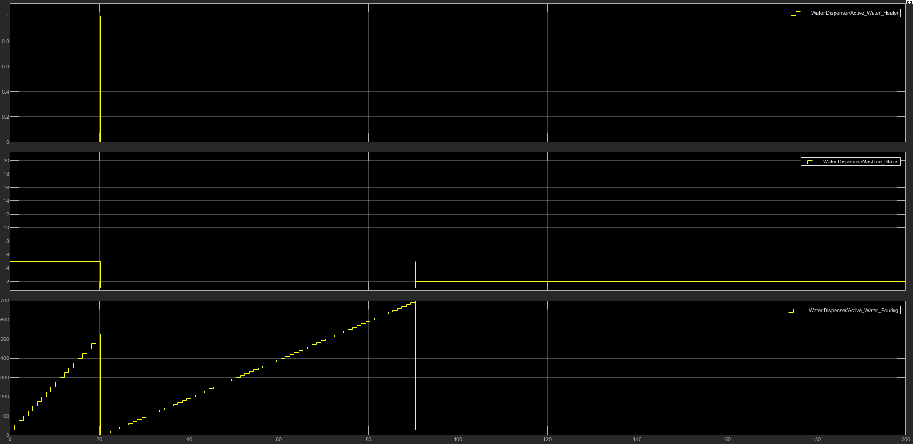

We can see that imediately after checking all functionality from SelfTest, the machine allow water to pouring. At second 90 we can see that Active_Water_Pouring has stop, because we have no water left. At the same moment we can see that the Machine_Status has changed the value from 1 (Working) to 5 (Testing ⬄ SelfTest) and then to 2 (No_Water). This happens because Cold_Water state is not directly connected to No_Water state, he go through SelfTest state first and then to No_Water.



* Hot_Water_Button = ON

Now, from Wait state, let’s supose that we deactivate Water_Button and activate Hot_Water_Button:

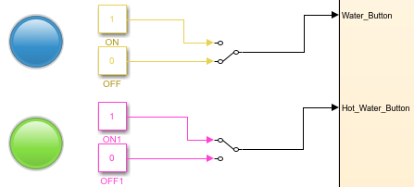

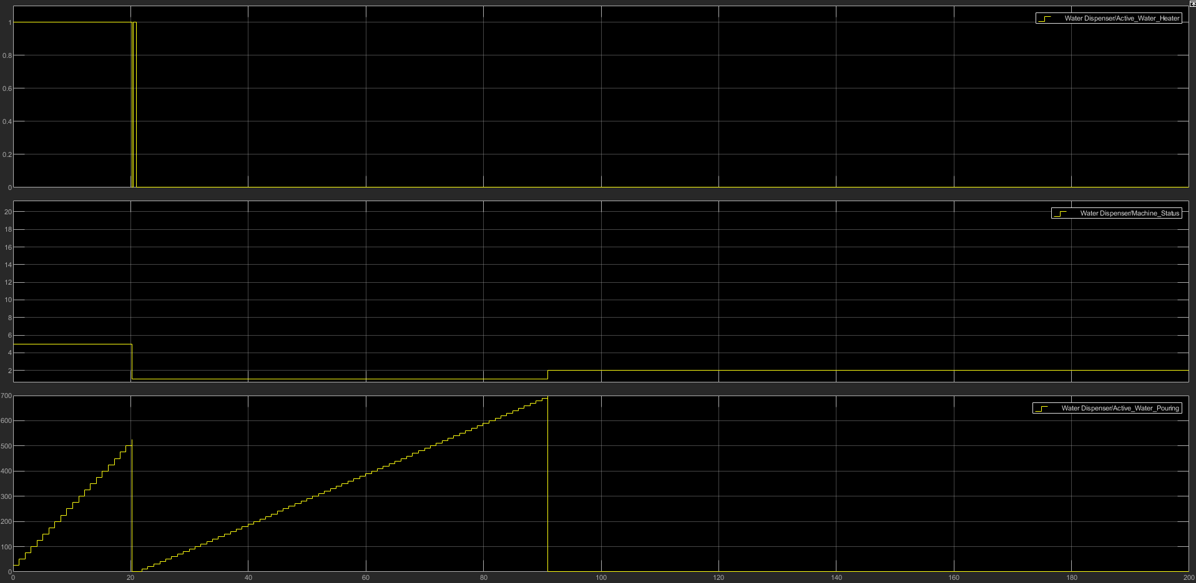

One difference between Cold_Water and Hot_Water is that here we activate Active_Water_Heater twice, once from SelfTest (for functionality of the system) and once for 500ms (to heat the water) before entry in Hot_Water.

Another difference is that here Hot_Water is directly connected to No_Water state, and that is why Machine_Status go from 1 (Working) to 2 (No_Water) and not from 1 to 5 and then to 2.



* Water_Button = ON || Hot_Water_Button = ON (not in the same time)

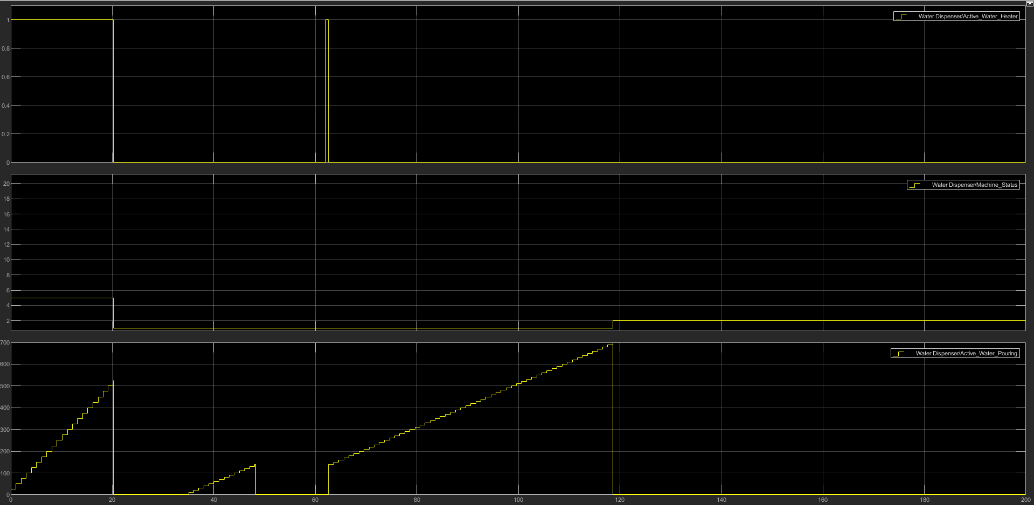

We can observe that:

1. From second 0 to 20: the system test the functionality of the system.
2. From second 20 to 47: the Water_Button is activated and the machine drop 150ml cold water. Machine_Status has been changed from 5 (Testing) to 1 (Working).
3. From 47 to 73 sec: the Water_Button is deactivated and the machine to nothing.
4. From 73 to 117 sec: Hot_Water_Button has been required. Active_Water_Heater has been activated for 500ms. After this 500ms, the system allow to pouring untill we have no water left.
5. From second 117 to end: Machine_Status has changed from 1 (Working) to 2 (No_Water).



* No Water (from the beggining)

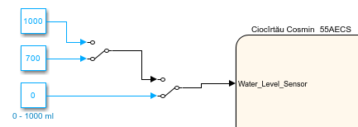

The outputs look like this:

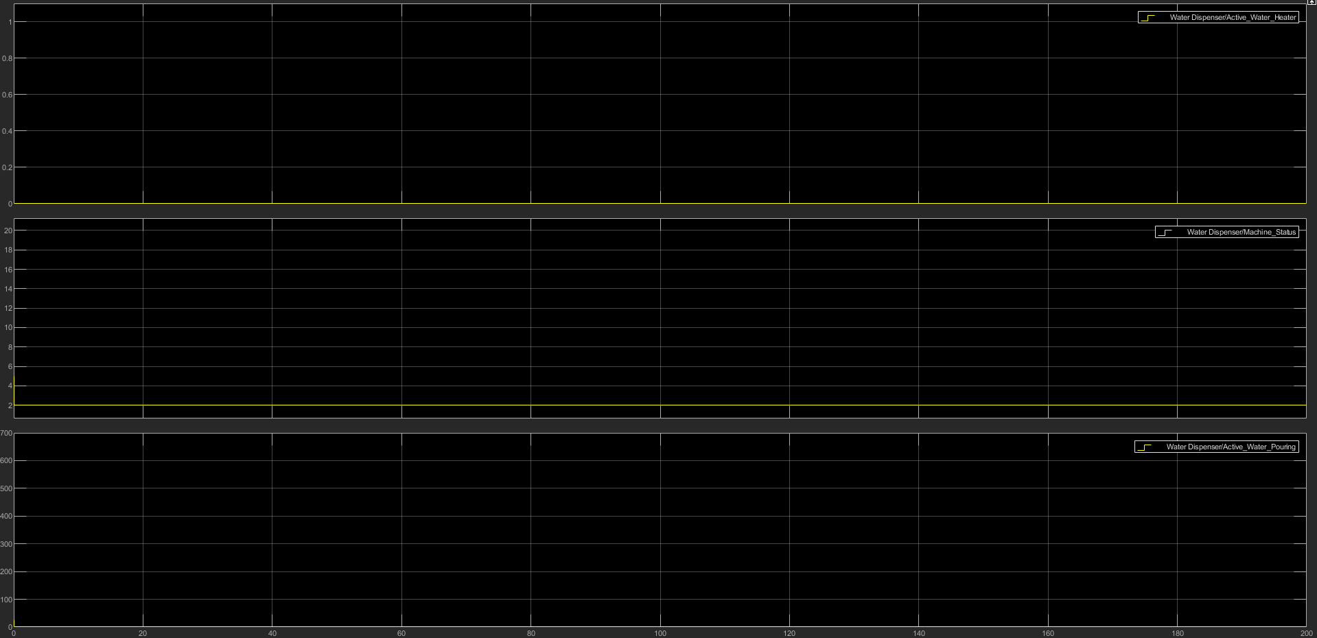

Exactly! All are on 0. If we don’t have water is not needed to test another functionality. Because, as I said at the beggining, a water dispenser is useless without water.



* Heater Fault

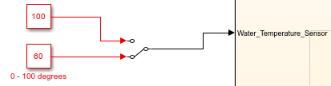

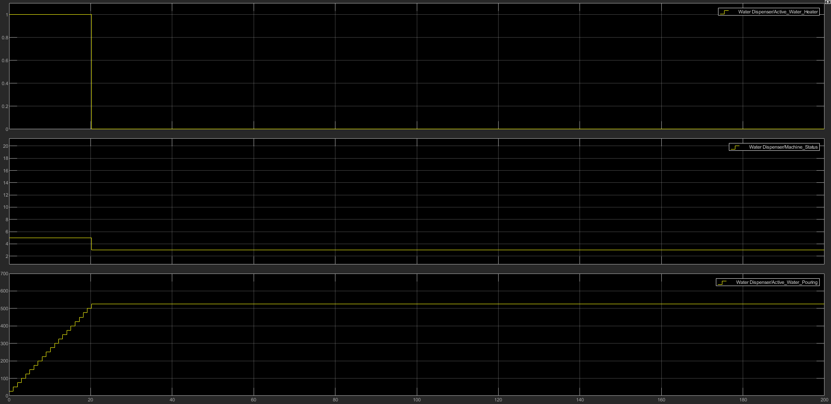

We can see that in the first 20 seconds the system keep Active_Water_Heater ON and try to heat the water. But imediately after these seconds the system see that he can’t reach 99 degrees in this time and he turn OFF Active_Water_Heater and the Machine_Status goes from 5 (Testing) to 3 (Heater_Fault).



* Pouring Fault

Let’s see what’s happen if the system can’t drop at least 50ml in 2 seconds and he drop only 30ml in 2 seconds:

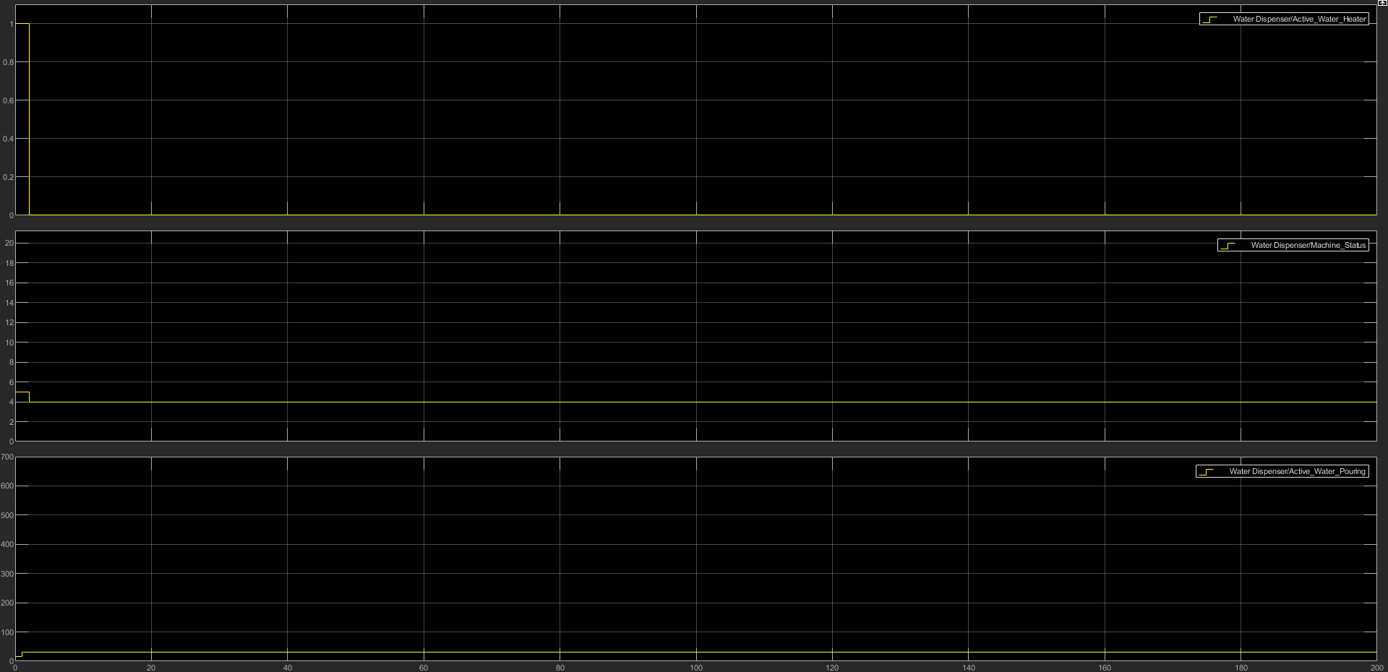

The system see that he couldn’t drop at least 50ml after 2 seconds and he know that there is a problem with the pouring mechanism. After 2 seconds Active_Water_Heater is deactivated, Machine_Status goes from 5 (Testing) to 4 (Pouring_Fault) and Active_Water_Pouring is also deactivated.



* IDLE state

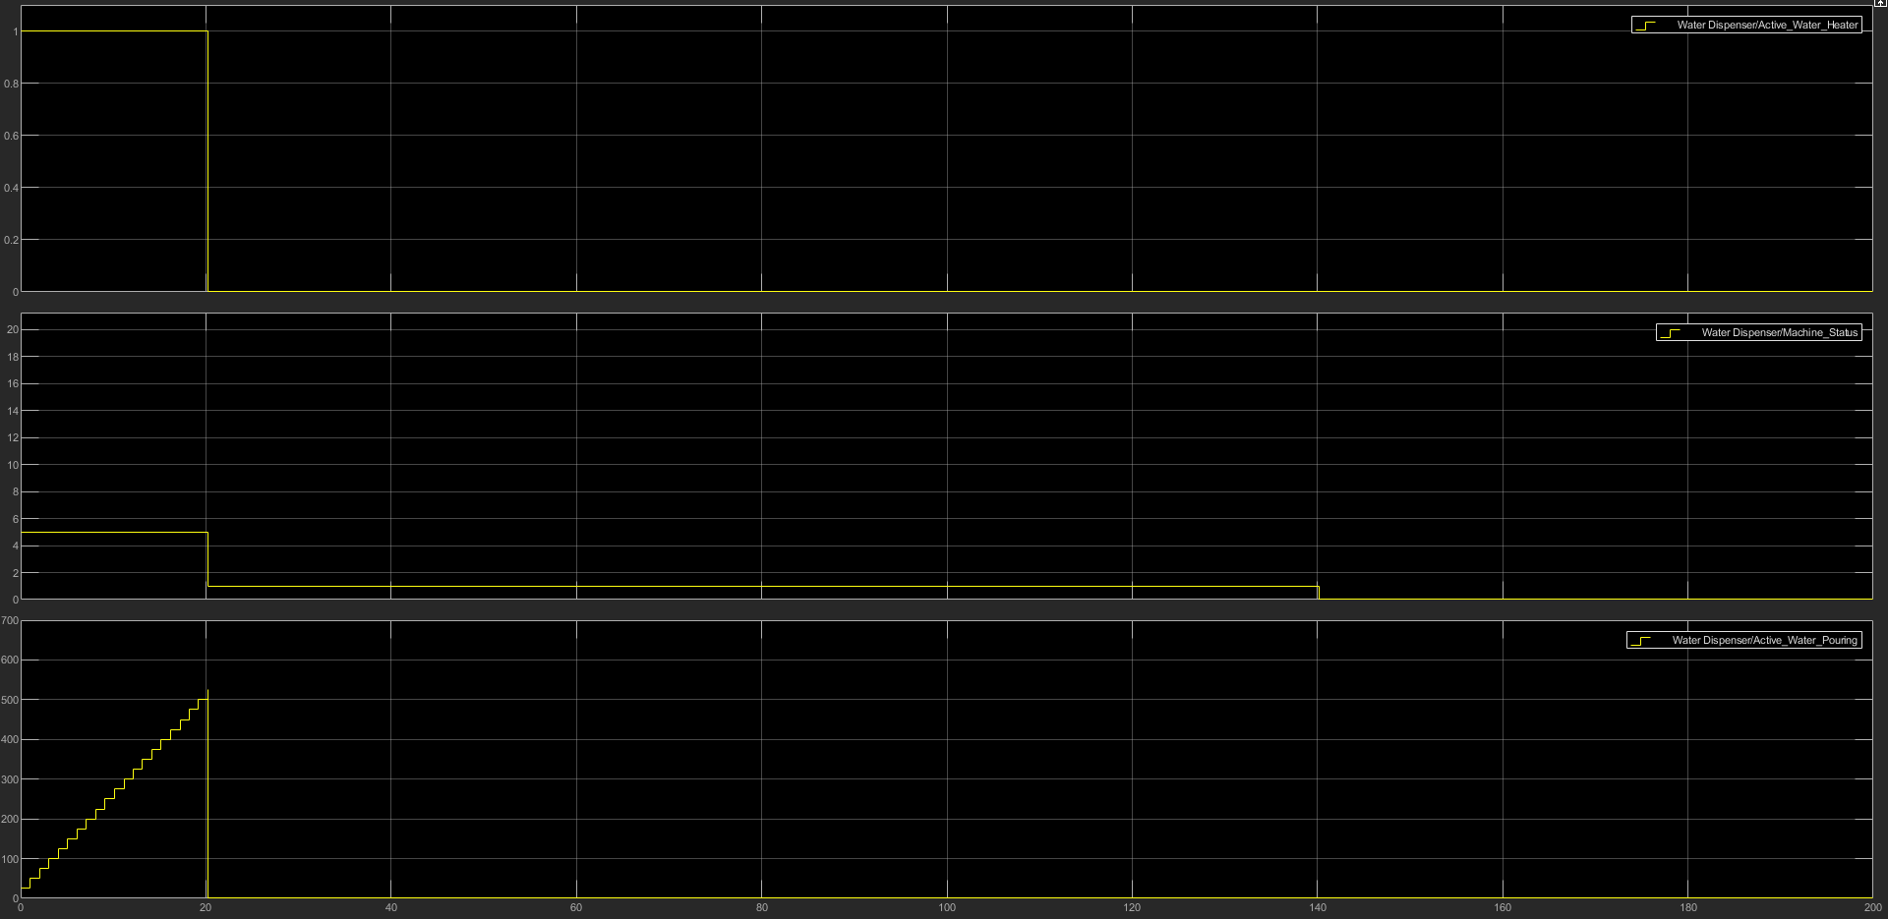

The system enter into ultra power saving mode after 120 seconds of inactivity. Machine_Status has been changed from 1 (Working) to 0 (Idle).



* More combination

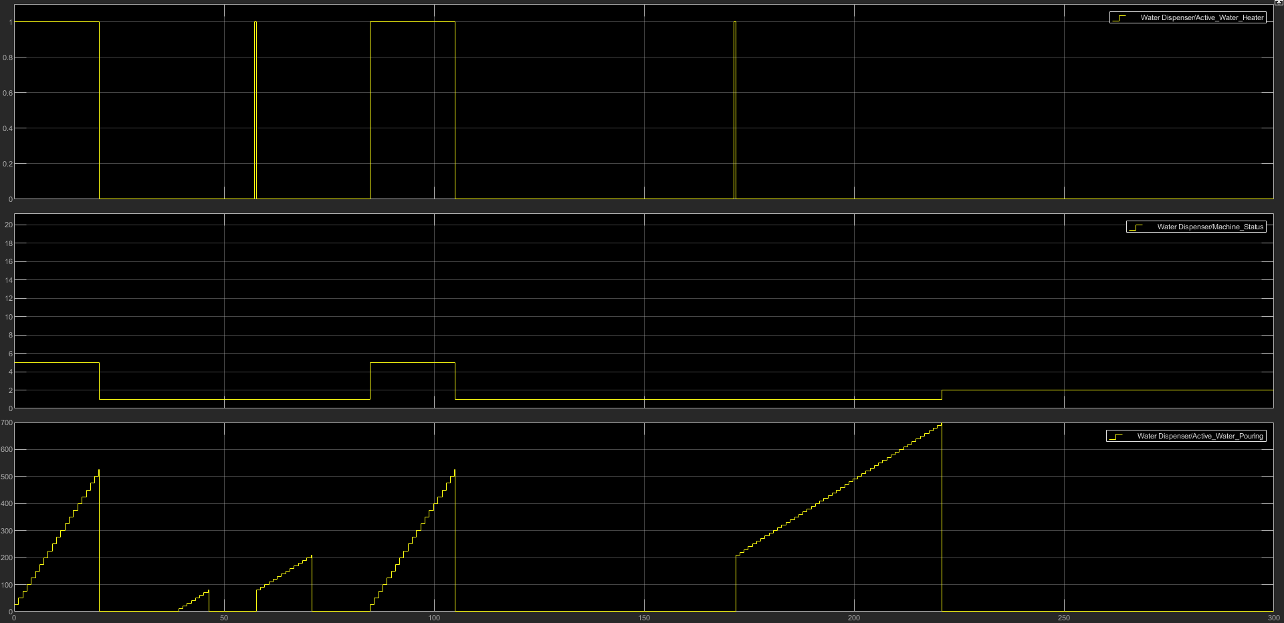

Let’s describe what happens above:

1. From second 0 to 20: The system start to test the functionality of the machine.
2. From second 20 to 40: The Machine_Status has been changed from 5 (Testing) to 1 (Working).
3. From second 40 to 46: The Active_Water_Pouring is activated.
4. From second 46 to 59: The system is in Wait state.
5. From second 59 to 59.5: The Active_Water_Heater is activated ⬄ require for hot water.
6. From second 59.5 to 70: The Active_Water_Pouring is activated.
7. From second 70 to 80: The system is in Wait state.
8. From second 85 to 105: The SelfTest_Button has pressed and the system start to test the functionality of the machine again. The Machine_Status has been changed from 1 (Working) to 5 (Testing).
9. From second 105 to 170: The system is in Wait state.
10. From second 170 to 170.5: The Active_Water_Heater is activated ⬄ require for hot water.
11. From second 170.5 to 220: The Active_Water_Pouring is activated.
12. From second 220 to final: Active_Water_Pouring become 0 because we have no longer water. The Machine_Status has been changed from 1 (Working) to 2 (No_Water).

GitHub

In case that you want to simulate or see in more detail the project, I will let you a link to the GitHub project below. Please notice that I will keep the project public till the end of the semester.

https://github.com/Cosmin45/Matlab